SEMESTER 1, 2021/2022

CSCI 3301 CAAL Section 03

COMPUTER ARCHITECTURE AND ASSEMBLY LANGUAGE

**Lab 2**

**PREPARED BY:**

|  |  |
| --- | --- |
| **NAME** | **MATRIC NO.** |
| MOHAMED MOUBARAK MOHAMED MISBAHOU MKOUBOI | 1820705 |

LECTURER:

Dr. HAFIZAH BINTI MANSOR

1. Figure 1. xori instruction during Instruction fetch (IF) cycle.

PC = PC + 4

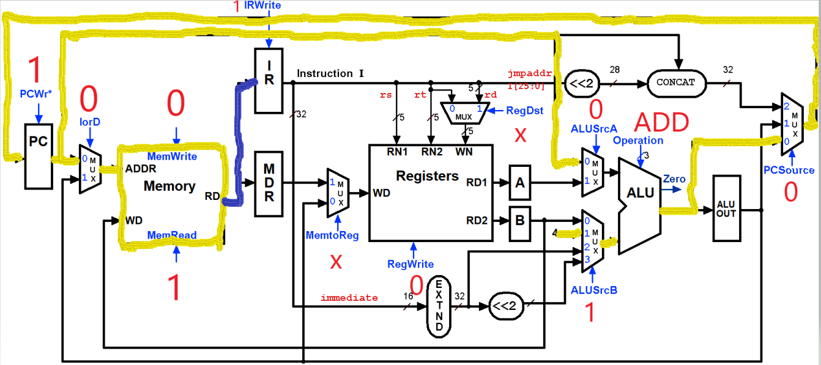

1. Figure 2. add instruction during Instruction decode (ID) cycle.

A = REG [ IR [ 25 - 21 ] ]

A = REG [ IR [ 20 - 16 ] ]

ALUOut = PC + (signe-extend (IR [15 - 0 ]) << 2 )

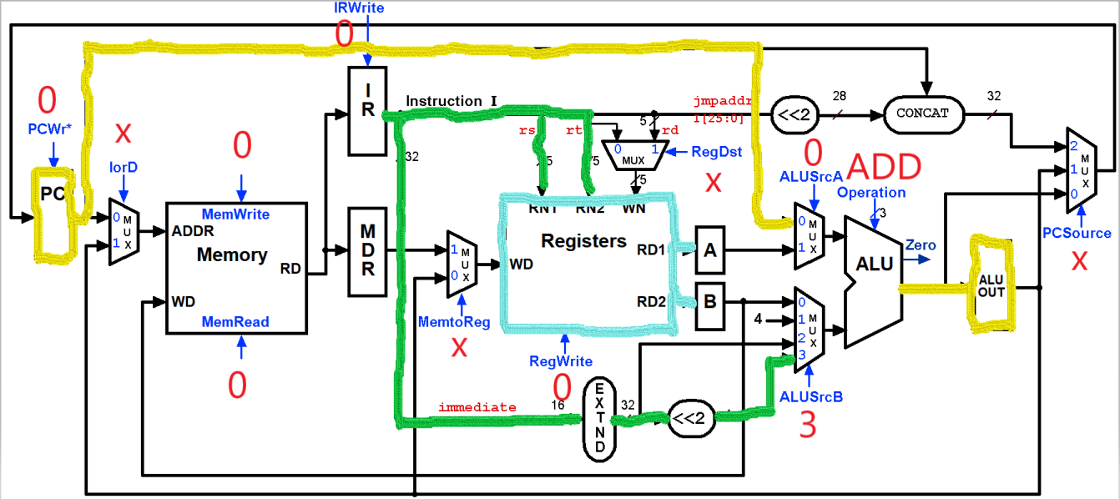

1. Figure 3. beq instruction during Execution (EX) cycle.

If ( A == B) then PC = ALUOut

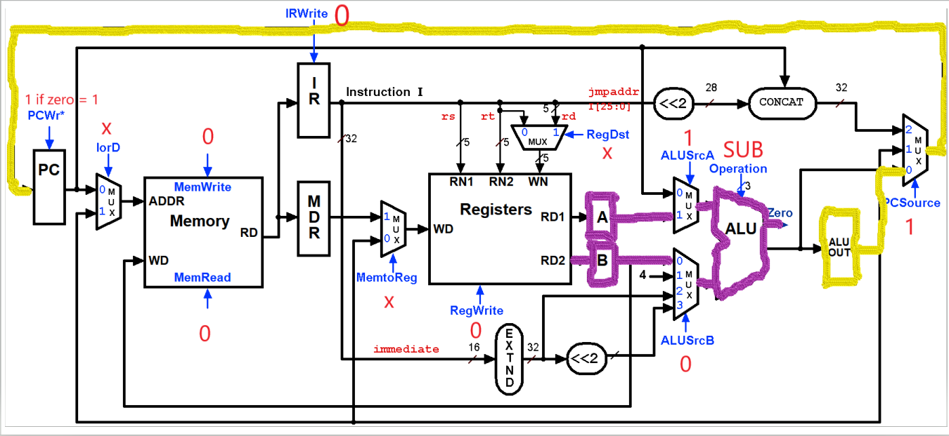

1. Figure 4. sw instruction during Memory access (MEM) cycle.

Memory [ ALUOut ] = B

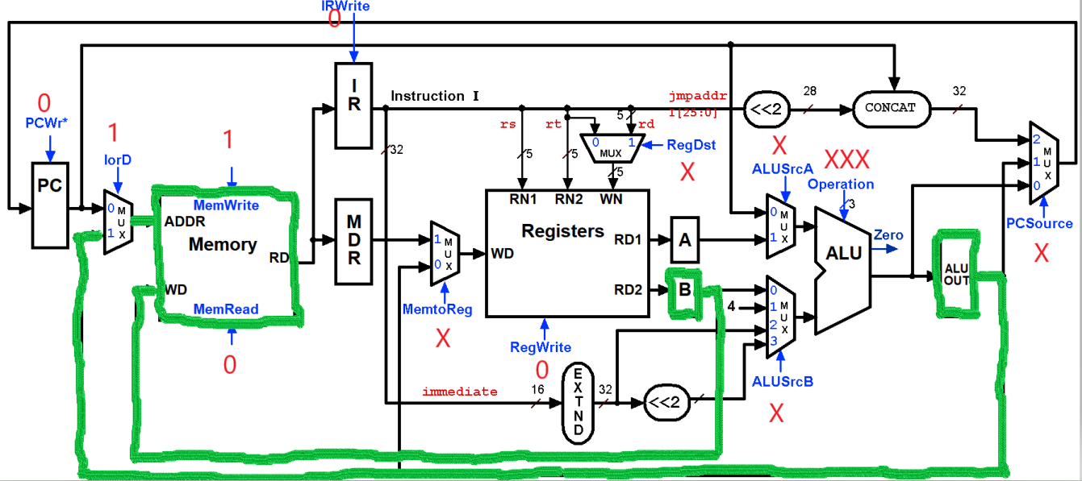

1. Figure 5. lw instruction during memory read completion (WB) cycle.

Reg [ IR [ 20 - 16 ] ] = MDR

